|  |  |
| --- | --- |
| Name: | Vakul Sharma |
| Age: | 27 |
| Highest Degree: | Bachelor of Engineering |

**Questionnaire**

Background Information:

* Figure shows patterns of movements to several locations of a user.
* The different locations are indicated as numbers (1, 2, 3..) on every hour basis.
* Example: On 8th day, between 7 am and 8 am, user is at location 3.
* Add what to focus on
* Add another question. Low confidence, medium and high confidence.
* Think about it what is the goal?
* Intuiative has to be matched.

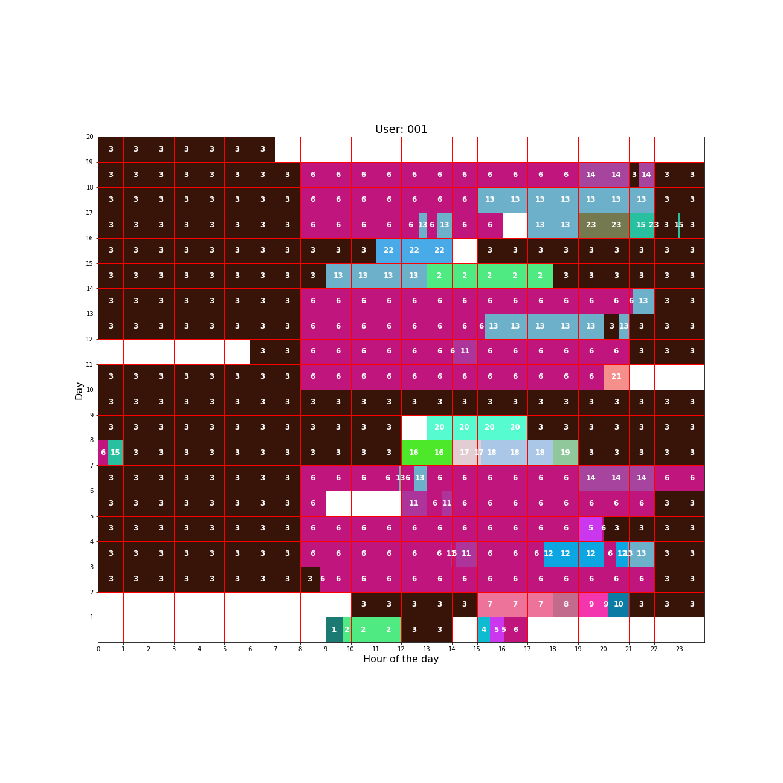Question: How long will the user stay at location 6(Work) if he was observed at location 6 (Work) at 8 am.

Hour

Answer: 9 pm